Nodal Ninja SPH-2
User Manual
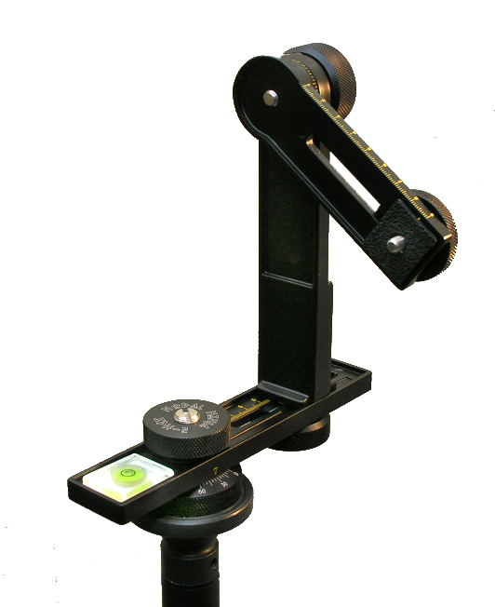

Nodal Ninja
A Panoramic Tripod Head
”what’s in your bag?”

Table of Contents

Introduction

About Parallax
Parallax defined
Parallax Demonstrated

Features

Parts & Specifications

Assembling the Nodal Ninja

Mounting the Camera

Know Your Nodal Point

Positioning Camera to the Lens Nodal Point
What is the Nodal Point and Why is it Important?
Finding the nodal point

Warranty

Copyright Information

Introduction

Congratulations on your recent purchase and welcome to the exciting world of panoramic photography.
Panoramic photography is one of the fastest growing segments of photo imagery today. With developments in hardware and software this technology allows for seamless stitching of multiple images.
If you take simple two shot panoramic images or complex 100+ shot super mega pixel mosaics, the Nodal Ninja is designed to eliminate parallax inherent when shooting adjacent images.
Our panoramic tripod head is a quality piece of equipment designed to give you many years of use.
Nodal Ninja is shipped in its foam lined carry case and come partially assembled.

About Parallax

Parallax defined:
Parallax is the apparent shifting of a foreground object to a background object when viewed at different angles or perspectives. With panoramic photography, multi-shot images and mosaics, as well as QTVR’s parallax error creates serious problems. This is because each image shot is actually different from the one before it due to the minor shifting of objects in the field. Seamless stitching of adjacently shot photos is very difficult whenever parallax is prevalent. Things simply won’t line up properly.
Parallax Demonstrated:
Hold your thumb out in front of you at arm's length and view it with your right eye (left eye closed). Move your head back and forth while remaining focused on the background and you’ll see your thumb move back and forth – this is caused by parallax. The apparent movement of foreground objects to backgrounds and perspective changes. This is the same thing that happens when a camera is on a tripod. Tripods are NOT designed to eliminate parallax with panoramic photography.

Using a special head like the Nodal Ninja and adjusting it properly so it rotates about the “nodal point” of a lens will eliminate virtually any parallax.
Features

Nodal Ninja SPH-2 features:
- FULL rotation UP - on most DSLR’s w/ model SPH-2L
- Detents - 15º click stops on the horizontal axis providing 24 stops in 360 degrees.
- Size - the smallest panoramic tripod head on the market today.
- Weight - only 658 grams (1 lb. 10oz.).
- Sturdy - “all metal” aluminum construction.
- Adjustable resistance for horizontal panning.
- Easy to assembly - no tools required.
- Leveling - built-in quality bubble level for exact leveling.
- Finish - attractive “non-glare” mat black.
- Ease - large easy to turn knurled edge adjustments knobs (great with gloves in cold weather)
- Demarcations - easy to read in horizontal and vertical axis.
- Rail rulers - remember your set points with different lenses.
- Closed rail design - assures your expensive camera won’t slip off accidentally.
- Small Rotator Base - means lesser footprint to edit out when doing spherical panos.
- Rail Indentation - for personalized label.
- Case - hard shell, dual zippered, and foam lined.
- Customer support - top notch.
- 2 year Warranty - we’ll replace any part that breaks due to manufacturer defects.

Parts & Specifications

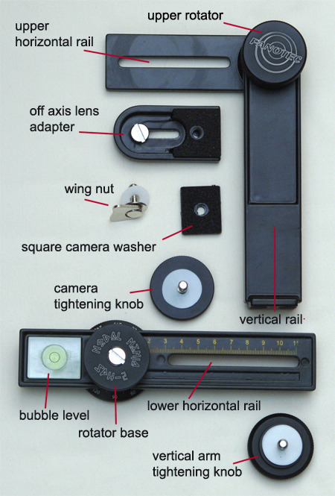
Nodal Ninja is shipped partially assembled.
The picture above shows all the parts as shipped (less included case).
The following parts and specifications will help to determine if Nodal Ninja SPH-2 is compatible with your camera. We ask you to also review our website (www.NodalNinja.com) for an updated list of cameras that will work.

- Max loading: approx 6.5lbs (3kg) for tripod mount.
Notice that this value is obtained indoors. External factors such as winds, unstable surfaces (i.e. boats) may reduce the stability of any pano head. We recommend a quality tripod for good stability. Some inexpensive tripods have “wobble” in the neck and/or do not maintain good level when rotating the head.

- Lower Rail Horizontal adjustment:
1 7/8” (47mm) to 4 1/8” (107mm)
Lower horizontal rail assembled with bubble level and rotator base.
The lower horizontal rail is used to slide the upper vertical rail into 1 of 2 nodal point positions. The rail has a laser engraved scale in 1 mm interval just like a standard ruler. The grooves of the scales are filled with water resistant paint to increase clarity. There is also a recessed area on the horizontal rail which would allow for a custom label or to mark the numerical values for the horizontal adjustments.
The lower rail assembly incorporates a rotator base with detent plate. This detent plate allows for 15 degree click stops while rotating on the horizontal axis. The rotator base is also engraved with demarcations in 5 degree intervals, with long marks at 15 degree intervals. Numerical values from 0 – 330 degrees are engraved in 30 degree intervals. You may tighten the rotator base to adjust the desired rotating tension. To set the tension loosen the inner screw using a coin or standard screwdriver, hand tighten the knurled knob (with SPH-2 markings) to desired tension, and then tighten inner screw to lock the tension. Note that you MUST rotate in CLOCKWISE manner; otherwise, the tightening knob may loosen.
The bubble level is used to level the Nodal Ninja by centering the bubble in the center ring.
- Vertical Rail:
  - SPH-2S: (short vertical arm)
Height: 4 ½ inches (114mm) from lower horizontal rail to center of upper rotator arm. The “S” model (short arm) is primarily designed for small prosumer cameras with built in lens and users of D-SLR’s NOT needing full rotation up.
  - SPH-2L: (long vertical arm)
Height: 6 ¼ inches (160mm) from lower horizontal rail to center of upper rotator arm. The “L” model (long arm) is primarily designed for users of D-SLR’s. The longer vertical arm not only accommodates longer lens but allows for full rotation up.
- Upper Horizontal Rail Adjustment:
Measured from upper center rotator to tripod mount point.
1 1/8 inch (30mm) using wing-nut to 3 ½ inches (90mm)
with off axis camera adapter – 1 1/8 inch to 4 7/8 (125mm)
The upper horizontal rail incorporates the upper rotator, with 5 degree demarcations less numerical values, allowing for panning and down. The upper rail is also used to adjust the cameras second of 2 nodal point positions.

- Off Axis Camera Adaptor:
½ inch (130 mm) to 1 ½ inches (39 mm)
Note: optional off axis camera adapters are available if needed.
The off-axial camera adapter is covered with a high quality rubberized slip-resistant material. This protects your camera from scratches and keeps it in proper position. Other sliding/ movable parts are also covered with the same material. For the axial and off-axial adjustments, scales are engraved on both sides of the arm or plate. On the end of the off-axial adapter, there is a mark to indicate the midpoint of the adapter, and hence the position of the tripod mount.

- 1/4” camera wing nut.
This is an optional nut that may be used is some circumstances to mount the camera to the Nodal Ninja’s upper rail. Using the wing nut also allows for the full rotation up with D-SLR’s.

- 2 3/16” black knurled tightening knobs.

  - The heavier knurled knob, with raised inner edge, is used to tighten the vertical rail to the recessed lower horizontal rail.
  - The thinner knurled knob is used to tighten the camera to either the upper rail (used in conjunction with the square rubber washer) or directly to the off-axis adapter plate which itself attached to the camera. This knob may or may not be needed.

- 1 square camera washer.
The square camera washer is made of high quality and durable polymer rubber. This square camera washer allows you to mount your camera (with tripod mount under the lens axis) directly to the vertical rotator arm without using the off-axis camera adapter.

Assembling the Nodal Ninja

Putting Nodal Ninja together is simple as it comes partially assembled.

1). Open the zippered case and familiarize yourself with the parts inside. You may or may not need all the parts.

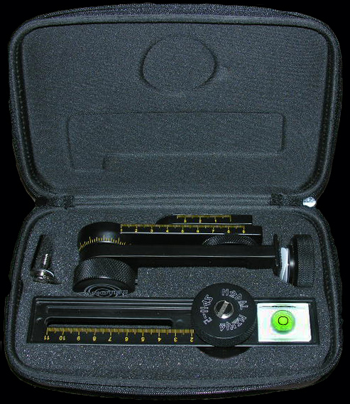
SPH-2S shown

2). Determine if the off axis camera bracket will be needed. Look at the base of your camera and note the position of the 1/4” female tripod mount. If this tripod mount is off center from the center portion of the lens you’ll need to use the small camera bracket.
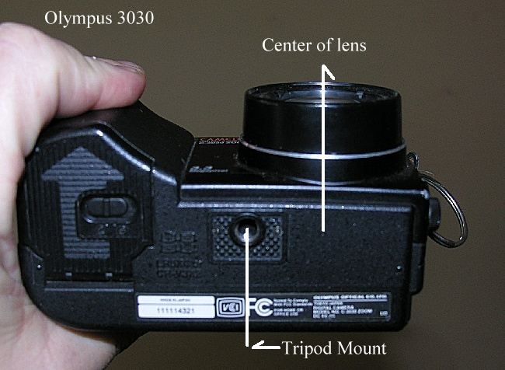
Note position of tripod mount to the actual center of lens or barrel of the lens.
Most small prosumers cameras have this offset.
3). Position the bracket so the adapters thread mount is directly inline with the lens axis.
Tighten with small coin or screwdriver.
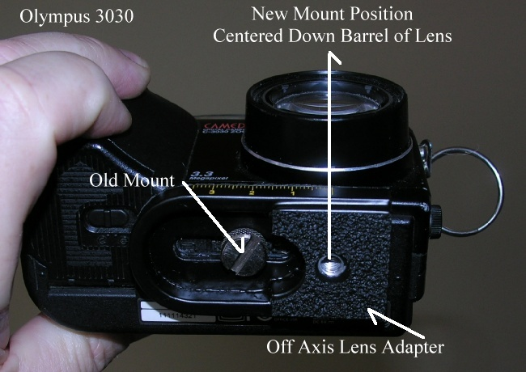
Note how the new camera mount is now inline with the center of the lens.

3). Next attach the vertical arm to the lower horizontal rail. You want to mount this with the upper rotator knob (FANOTEC markings) facing outwards. Slide this vertical arm to the outside of the rail before tightening.

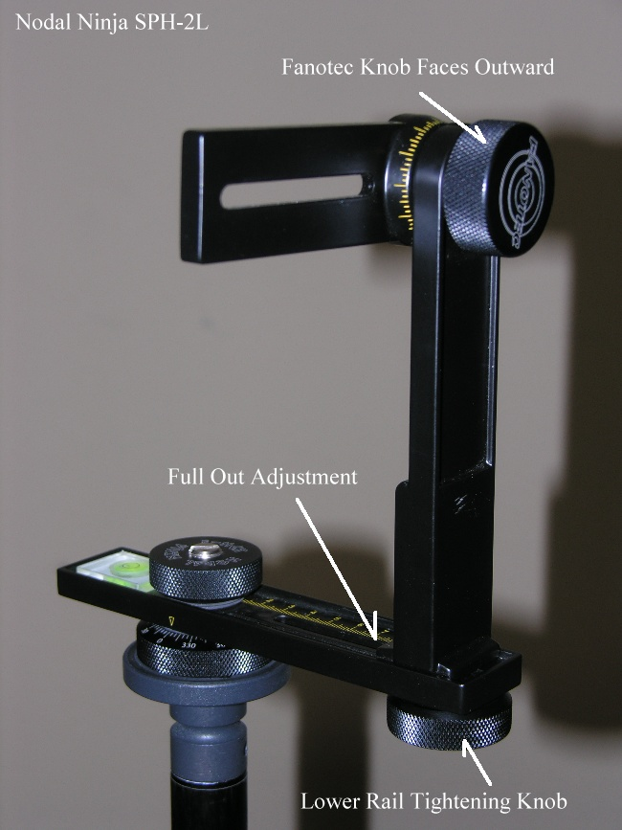
Vertical arm attached to lower horizontal rail.

4). Attach Nodal Ninja directly the tripod neck as shown above or a tripod head using quick release plate. Attaching directly to the tripod neck will give you a smaller tripod footprint if you need to shoot directly down. Attaching to an optional tripod head with quick release plate will also give you a bit more flexibility and ease in leveling the Nodal Ninja.
Mounting of the Camera

Mount your camera to the Nodal Ninja’s upper horizontal rail. Depending on the camera and lens you can use different combinations as shown below. Note the hand grip of the camera is always positioned so it’s on top.

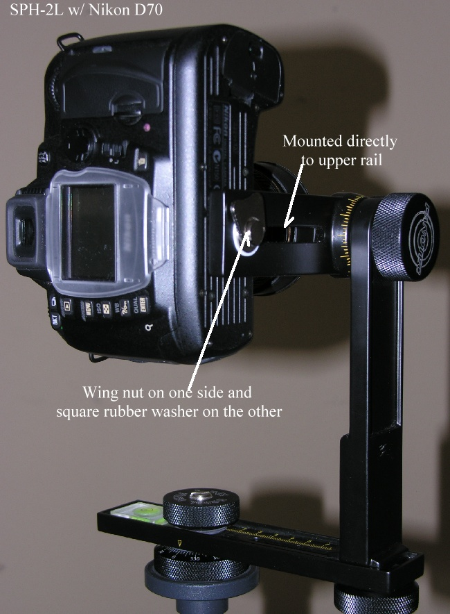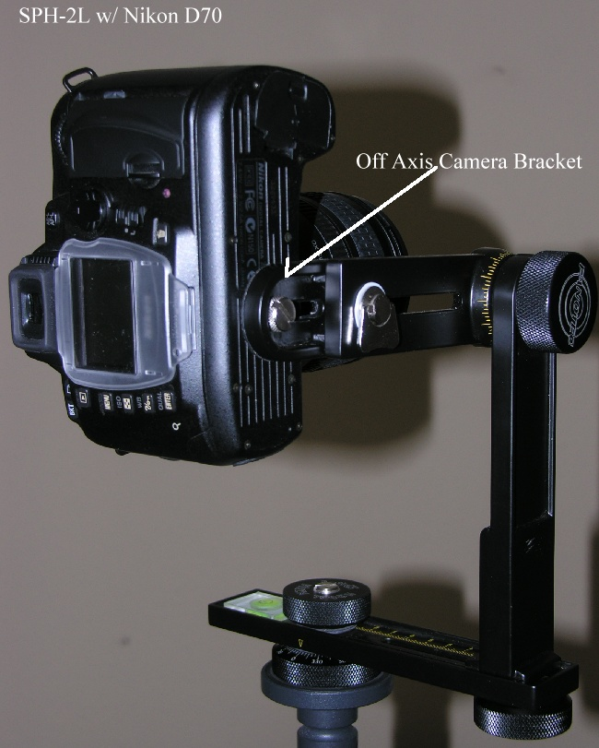
If mounting directly to the upper rail (without the off axis lens adapter as shown on left) make sure you use the wing nut and square rubber washer.

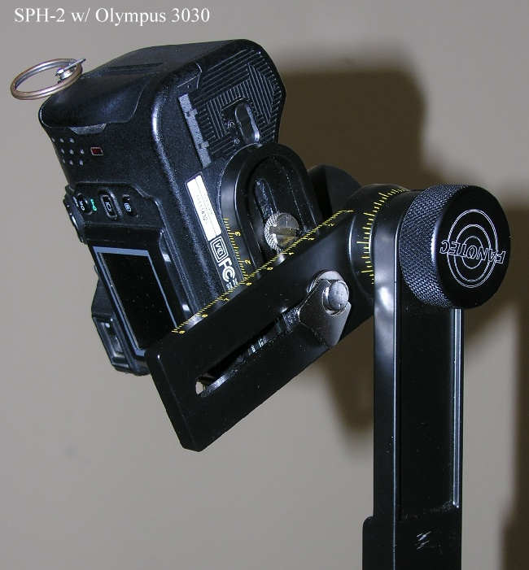
Positioning Camera to the Nodal Point of the Lens

What is the Nodal Point and Why is it Important?
The nodal point of a lens is the point inside a lens where light paths cross before being focused onto the CMOS, CCD or film plane. Although technically incorrect the nodal point is sometimes called the entrance pupil. When taking adjacent images you want to rotate the camera around a line that runs through (or very close to) the nodal point inside of the camera lens. By finding the nodal point of lens, and rotating the camera about this axis, will assure parallax free images. Parallax is more obvious to closer objects in the viewfinder. The more distant the objects the lesser the parallax. If using a lens with zoom capability the nodal point will change as the zoom change. Because of so many variables it is best to learn how to find the nodal point manually.
Now that your camera is mounted to the Nodal Ninja, as explained above, we need to find and set it up so the camera rotates properly around the lens nodal point. The nodal point will vary from lens to lens and will also vary depending on the focal length you use. We encourage you to learn to how to find the nodal point of your lens manually. Specific information you find elsewhere with respect to where a nodal point may be located on a lens should be taken with a bit of concern to accuracy. Once learned how to find your nodal point it’s relatively quick and easy. In this example we’ll use the popular Nikon D70 w/ 10.5 mm Nikkor lens.

Finding the nodal point:
There are only two adjustments needed – lower and upper.
1). Set the lower rail adjustment by pointing the camera directly down. Do this by loosening the upper “Fanotec” knob and rotate your camera to it is pointing straight down to the ground. Next loosen the lower adjustment knob, the one that tightens the vertical arm to the lower rail. Slide the vertical rail inwards on the lower rail until the lens is centered directly over the lower rotator. Once centered note the position on the ruler and tighten the lower adjustment knob. Your first nodal point is set and will not change regardless of lens or focal length.
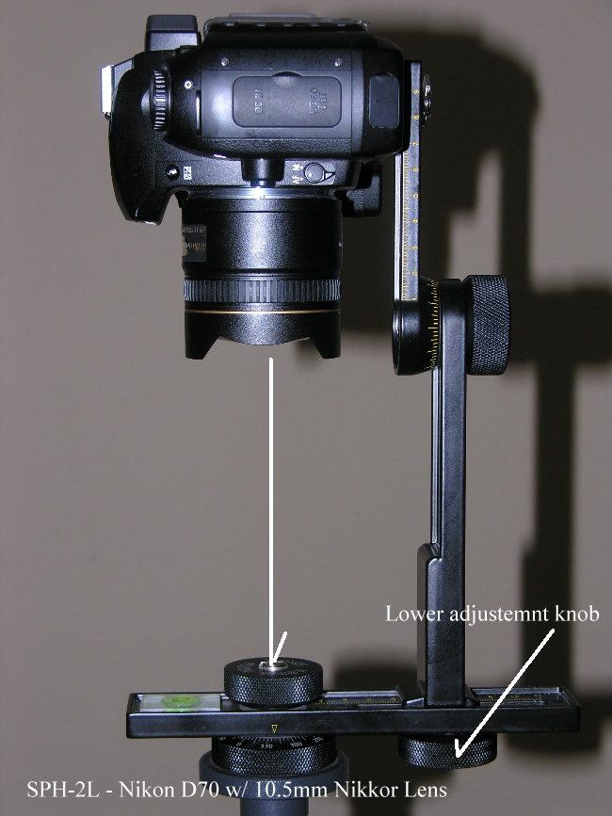

2). Loosen the upper Fanotec knob and rotate the camera so it points straight out or parallel with the ground. This position is known as 0 degrees. You want the camera as far back on the upper rail as possible.

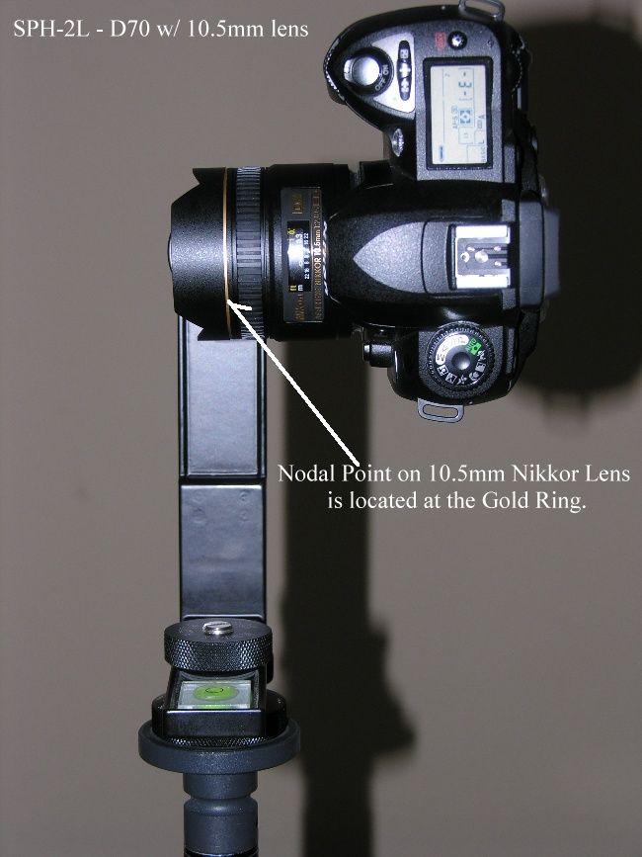
Cheater note: On the 10.5mm Nikkor Lens the Nodal Point
is located at the gold ring on the lens. But we’ll proceed as if we
don’t know this or if using a different lens.

3) Position in front of the camera two objects – one nearer than the other. For example indoors you could use two lamp poles or if outside try using two fence posts or light poles. Any two objects creating a vertical line will work as long as one is positioned behind the other. In this example we’ll use two floor lamps.
4) Looking inside the viewfinder, or at the LCD screen, rotate the camera so the two objects are towards the left side of the frame. Note the exact position of the two lamps. Ideally place the lamps so they aren’t directly behind each – slightly offset them. Note the apparent distance between the two lamp poles as shown below.

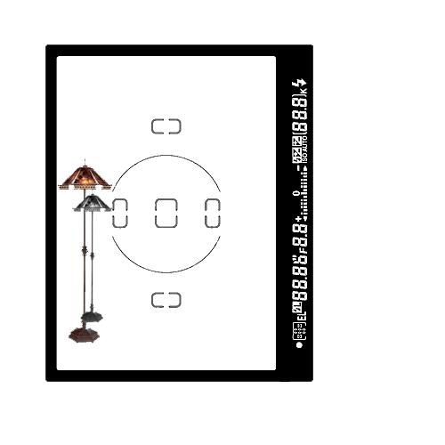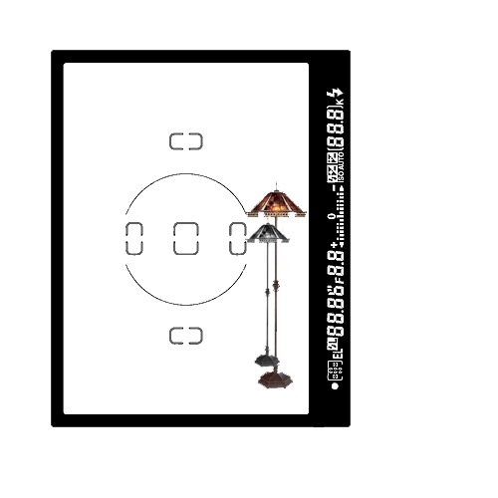

5) Now rotate the camera so the two objects are now in the right side of the frame. Go back and for the a few times and watch to see if the distance between the two poles change. If the distance changes, even slightly, then you have parallax and you’ll need to move the camera and lens slightly forward (or back) on the upper rail.

6) Loosen the wing nut and move the camera forward approx ½ inch (10 mm) and tighten.
Repeat step 5 until the lamps remain relatively unchanged as shown below.
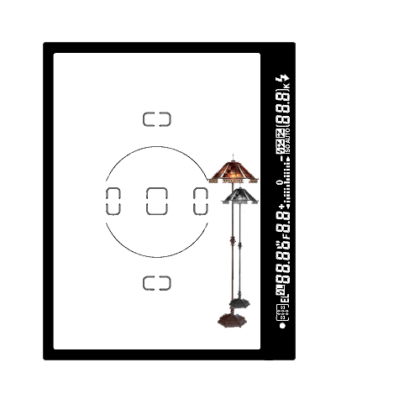

7) Note the position on both upper and lower rails. If you change cameras or lenses you’ll need to repeat the above steps. That’s it! It’s good to be close as possible to the nodal point, depending on the lens being used, sometimes it’s difficult to note much change with the objects set up. If you’re having difficulty noting object move (i.e. wider angler lens) when making minor adjustments try moving the lamp poles closer to the camera.

Warranty

Nodal Ninja SPH-2 is a quality instrument. Under normal usage it will last many years. We feel so confident our product will stand the stand of time we are issuing a 2 year warranty from the date of your purchase – one of the best in the industry. In the unlikely event a part wears, tears, or breaks simply contact us for a replacement part. We will replace any part that is deemed to be defective at no cost to the consumer other the cost of postage to send it in. Customer abuse or misuse (to be determined by manufacturer and/or distributor) will void any implied warranty. This warranty is issued to the original buyer only is non-transferable.
The manufacturer (Fanotec) and/or distributors also assumes no liability for damage caused to equipment, or downtime time caused as a consequence of not being able to use our product, or injury caused to persons using Nodal Ninja.
As with any piece of equipment, use it carefully as it is designed to be used and it should last many years. We don’t want to get into a lot of expensive legalize, but we would like the buyer to understand and accept at time of purchase ALL responsibilities that arise out of the use of our products either directly or in directly.

Copyright Information

All text and images on our website and in this manual are copyrighted under US and International laws and cannot be reused in any part without written permission of both Fanotec and Circular Worlds. Any questions please contact: copyright@nodalninja.com

